
Lesson 5: Enemy Ranks
TIC-80
VIDEO GAME CREATION
This week: one enemy becomes many. Your job is to turn last week's single enemy into a whole row of them, using a loop instead of repeating yourself by hand.
Open your own [YourName]Game project from Lesson 4 - don't start a new one. Everything this week builds on the enemy and collision detection you already have.
Tip: no new assets this week - you're reusing bullet_yellow.png, sfx_shoot.wav, enemy_invader_red.png, and sfx_hit.wav from your Lesson 3 and 4 Assets folders.

Setup
- Launch TIC-80 and load your cart from Lesson 4.
- Press Esc to reach the code editor.

Level 1 - Minimal (MVP)
Several enemies sit on screen in a row, created by a loop instead of placed or spawned one at a time. Shooting any one of them destroys just that one. This is a complete finish for today - reaching this is enough to move on to next week.
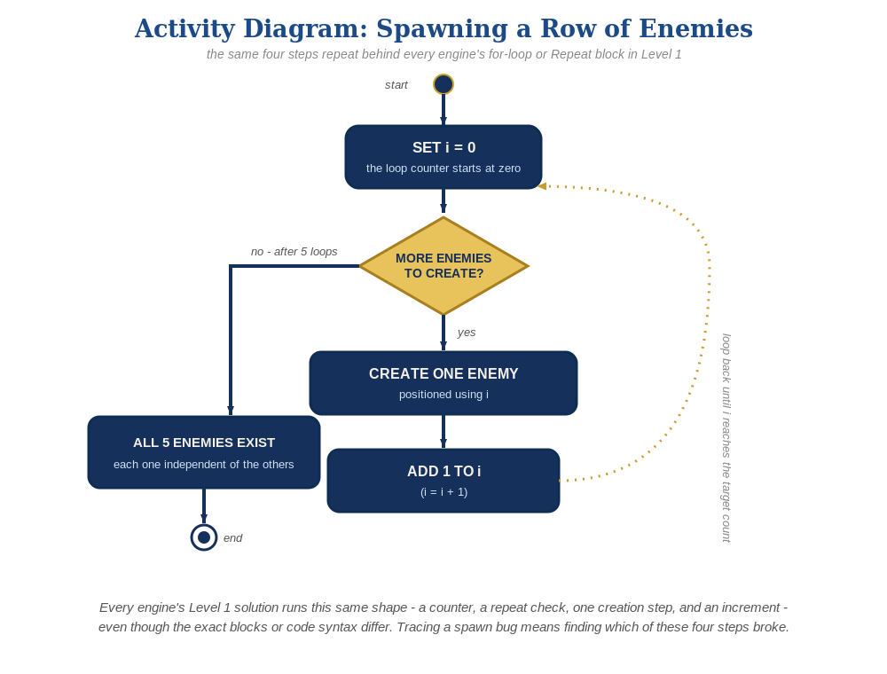
The spawn loop, in general - the same counter, repeat check, creation step, and increment behind Level 1 in every engine, whatever the exact blocks or syntax look like.
- Replace your single enemy_alive/ex/ey variables with an enemies table, populated by a for loop at the top of your code, above the TIC() function.
- Update the bullets loop so each bullet checks against every enemy in the enemies table (a nested loop), instead of just one fixed position.
- Update the drawing code at the bottom of TIC() to loop over the enemies table too, only drawing the ones still alive (code below).
- Press Esc, type run, press Enter, then shoot different enemies to test - each one should disappear independently when hit.
enemies={}
for enemy_count=0,4 do
table.insert(enemies,{ex=20+enemy_count*20,ey=10,alive=true})
end
bullets={}
function TIC()
cls(0)
if btn(3) then x=x+1 end
if btnp(4) then
table.insert(bullets,{bx=x,by=y})
end
for i=#bullets,1,-1 do
local b=bullets[i]
b.by=b.by-2
local hit=false
for j=1,#enemies do
local e=enemies[j]
if e.alive and b.bx<e.ex+8 and b.bx+8>e.ex and b.by<e.ey+8 and b.by+8>e.ey then
e.alive=false
hit=true
end
end
if hit then
table.remove(bullets,i)
elseif b.by<0 then
table.remove(bullets,i)
else
spr(2,b.bx,b.by,0)
end
end
for j=1,#enemies do
local e=enemies[j]
if e.alive then spr(3,e.ex,e.ey,0) end
end
spr(1,x,y,0)
end

Level 2 - Complete (Alpha/Beta)
Every enemy in the row can be individually shot and destroyed without affecting the others, and a bullet that misses every enemy still behaves exactly like it did last week.
- Shoot several different enemies in a row, including some misses - each hit sets exactly the one enemies[j].alive that was actually touched to false, and every other enemy is unaffected.
- The inner enemies loop checks every enemy for every bullet, every frame, so this naturally scales to any number of enemies without extra code - a hit stops mattering for that enemy immediately, since e.alive and ... guards the check the same way it did for the single-enemy version.

Level 3 - Refined (Ready to Publish) - pick any that interest you
- Sound: this already works with no changes - sfx(2) still fires from inside the same hit branch, once per actual hit, no matter which enemy or how many exist.
- Visual: draw a slightly different sprite index or use spr()'s flip argument based on each enemy's position in the table (j), for a bit of visual variety across the row.
- Structure: keep enemy state entirely inside the enemies table (never as loose separate variables again) - every new place that needs an enemy's position or status should read it from that table, the same way the bullets loop does.

If Something's Wrong
- Shooting one enemy removes all of them: confirm the alive flag is being set on enemies[j] specifically (e.alive=false), not on some variable shared by all enemies.
- Enemies don't line up in a row: confirm the spawn loop's ex=20+enemy_count*20 (or your chosen spacing) actually uses the loop variable enemy_count, not a fixed number.
- "attempt to index a nil value" error: confirm enemies={} and its populating for loop run before TIC(), at the very top of the code, same as bullets={}.

Want More?
Student Resource List > TIC-80 section, or tic80.com

